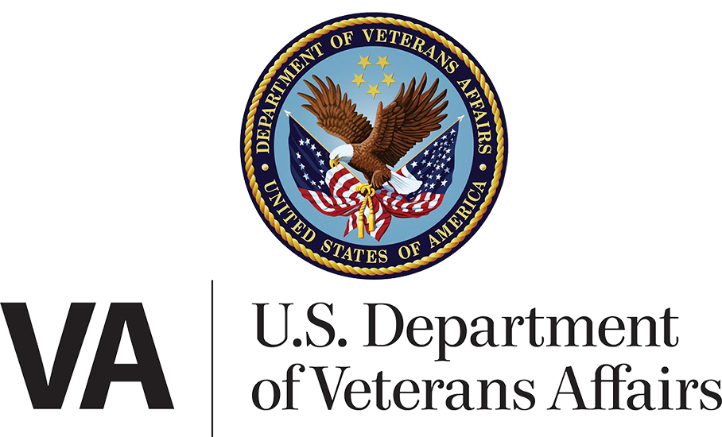

Department/CTO Health Team

June 4, 2025 | My HealtheVet on VA.gov Portal and Landing Page Product Guide

Version 5.1

Revision History

| **Date** | **Version** | **Description** | **Author** |
| --- | --- | --- | --- |
| 03/21/2023 | 1 | Landing Page debut | Marci McGuire |
| 06/04/2024 | 2.0 | Integration of tools on VA.gov w/MHV navigation | Wes Rowe |
| 12/11/2024 | 3.0 | Integration of MHV Account Creation API, new Medical Records tool on VA.gov | Wes Rowe |
| 3/13/2025 | 4.0 | Updating revised “no access to My HealtheVet” alert | Jonathan Nelson |
| 3/21/2025 | 5.0 | Combining “Landing pages, links, and sign-in widget updates” product guide with “My HealtheVet on VA.gov Portal and Landing Page” product guide | Jonathan Nelson |
| 5/20/2025 | 5.1 | Updating for Milestone 2: changes to landing page and to non-patient landing page (removal of no access alert) | Florence McCafferty |

Product updates for Milestone 2 (June 4, 2025) 4

Landing page updates 4

A new landing page for non-patient users 4

User Access 5

Alert case: Sign-in credential needs identity verification 5

Alert case: MHV User Account problem / API error (new Dec 2024) 6

**MHV Error codes** 7

New June 4, 2025 – Non-patient landing page (previously “no access” alert) 8

The new My HealtheVet experience landing page 12

Navigation within the new MHV experience 14

Navigation to the new My HealtheVet experience from VA.gov 15

Option 1: VA.gov header (from each page on the site) 15

Option 2: My VA 17

**For Veterans who have received care at an Oracle facility** 17

Option 3: The health care hub on VA.gov 20

## Product updates for Milestone 2 (June 4, 2025)

Starting June 4, 2025, all links to tools on the previous version of My HealtheVet will redirect users to the new tools on My-HealtheVet-on-VA.gov (known to Veterans as “the new My HealtheVet experience”).

This 6/4 date marks the end of the opt-in/opt-out period for the new My HealtheVet experience. Veterans will no longer have the option to “go back to the previous version.”

### Landing page updates

The changes to the landing page are summarized as follows:

* Edited introductory text (right under the My HealtheVet h1)
* Addition of a link to “Learn more about My HealtheVet on VA.gov”
* Removal of “Go back to the previous version” link
* Addition of link in the Medical records card: “Share your personal health data on the Share My Health Data website”
* Small changes to link lists under “VA health benefits” and “More health resources” toward the bottom of the page

More on these changes to the landing page starting on page 11.

### A new landing page for non-patient users

The previous version of My HealtheVet was available to any Veteran who wanted to create a username, not just those who are registered at a VA facility. Milestone 2 – June 4 – will be the first day that non-patient users will lose access to two features they could use on the previous version: adding self-entered health data and downloading pdfs of previously entered self-entered data, as well as some basic DoD information.

To continue to offer these non-patient users time to access their data, we created a non-patient version of the new My HealtheVet experience landing page. Moving forward from June 4, all users who are not registered with a VA facility in our records will land on the non-patient version of the landing page if they visit www.va.gov/my-health.

More details on the non-patient landing page starting on page 8.

## User Access

For a user to have access to all tools on the new My HealtheVet experience (including links to health tools as described in this document), they must meet the following criteria:

1. Signed into VA.gov with an identity-verified credential issued by either **Login.gov** or **ID.me**.
2. Previously registered at a VA facility
3. Their MHV UUID was successfully retrieved by VA.gov from the MHV back-end (a.k.a. the MHV Acct Creation API, new as of mid-December 2024)

***If these conditions aren***’***t met, the alerts below will display and some or all links on the Landing Page will be hidden.***

### Alert case: Sign-in credential needs identity verification

If a user’s signed-in credential is not ID-proofed (i.e., LOA3), the six main boxes on the landing page will be replaced by an alert informing the user of the issue and instructing them to sign in with an identity-verified account from either Login.gov or ID.me.

Figure 1. "Verify" alert for user who signed in with Login.gov credential

Figure 2. "Verify" alert for user who signed in with ID.me credential

The “Verify your identity” link will take the user into a verification flow provided by the credential provider (CSP), either Login.gov or ID.me.

### Alert case: MHV User Account problem / API error (new Dec 2024)

During the sign-in process, VA.gov must match the user to a back-end record in My HealtheVet through a MHV UUID. This matching, which uses the MHV Account Creation API, may occasionally return an error. Some errors are transient, due to server glitches. Others require manual intervention. See the table lower in this section for error codes and triage approaches.

MHV account errors will need to be resolved before the user can proceed with using Secure Messaging, Medications, and Medical Records on VA.gov. Links for this functionality on the Landing Page will be altered to indicate that they are impacted by the error.

This screenshot of an error alert is representative of all such alerts – they will vary only by the three-digit error code starting with “8” and will appear on the My HealtheVet landing page. The MHV Help Desk is the best option for Veterans to get these issues resolved, so that phone number is displayed within the alert. (See below for the possible error codes and their causes.)

Figure 3. MHV Account Error alerts include a code number that can be used to triage the cause of the issue

#### **MHV Error codes**

Most of the error codes require intervention by the MHV Help Desk. A few may be resolved by refreshing the page or signing out and in again.

|  |  |  |
| --- | --- | --- |
| **Error Code** | **Cause** | **Triage approach** |
| ***801*** | Multiple Active MHV Accounts found in MHV for user ICN and Deprecated ICN | MHV Help Desk: use the Profile Update button to resolve. If not resolved escalate HRC ticket to Tier 2. |
| ***802*** | ICN provided is not the Primary ICN | Could be caused in MHV back-end or other systems. Needs technical escalation. |
| ***803*** | For any other downstream MHV errors that stopped processing of the IAM Provisioning request in MHV | Veteran can try again later. Refreshing browser or signing out and in again should fix it unless there is a system outage. |
| ***804*** | User has a date of Death in MPI | MHV Account cannot be created if date of Death is accurate. |
| ***805*** | No active user account with ICN, but deactivated account found with ICN. | MHV help desk: reactivate their MHV account. |
| ***806*** | Multiple Accounts found with same Traits | MHV help desk: resolve manually. |
| ***807*** | User account found with Traits match, but MHV has a different ICN for that account | MHV help desk: resolve manually. |
| ***808*** | Invalid Token, Missing Token Value | User should try logging out and back in again. |
| ***809*** | A field passed to the MHV API is mis-formatted or missing | User should try logging out and back in again. |
| ***810*** | Upgrade to Premium Failed | Veteran can try again right away. |

### New June 4, 2025 – Non-patient landing page (previously “no access” alert)

The landing page no longer throws an alert when a user is not registered with a VA facility. Instead, when a user is signed in with an identity-proofed account and our data shows that they are not registered with a facility, they are brought to a modified version of the landing page. We are calling the modified version the “Non-patient landing page.” Both the default and modified versions of landing page are located at www.va.gov/my-health.

**The non-patient landing page**

This version of the landing page is different from the default My HealtheVet landing page in the following ways:

* Section with header “We don’t have VA records for you”
* Features to download self-entered and/or DoD data
* Link changes under VA health benefits and More resources
* Removal of links to health tools and secondary navigation bar

The section with the header “We don’t have VA records for you” explains to the user why they cannot use health tools on the new My HealtheVet experience, and what to do if they think they’ve arrived at the non-patient landing page in error.

NOTE: In rare cases this page may be erroneously displayed when a back-end system (e.g. MPI) has an incident and fails to provide data to VA.gov upon login. If a Veteran incorrectly arrives at the non-patient landing page, check for system outages/incidents if possible, or tell them to try again in a few hours. If the alert persists, the Veteran should contact the My HealtheVet helpdesk to get help checking if they’re registered to any facilities.

Figure 4: Section at top of the non-patient landing page explaining why users have arrived at this page (no facility registration)

Veterans who have used the classic My HealtheVet in the past despite not receiving VA health care benefits will officially be barred from using health tools on classic or the new My HealtheVet experience at Milestone 2 on June 4, 2025.

The “Download your data” section of the non-patient landing page provides these users with the data they were able to access on the classic version of MHV. Some users will have self-entered data to download if they used the classic version of MHV to input their own data. Some users will have DoD data to download if they are Veterans.

Figure 5: Section of the non-patient landing page where users can download data despite not being a current recipient of VA health care benefits

Figure 6: Full non-patient landing page (for all signed in ID-proofed users NOT registered at a facility

Figure 7. The new My HealtheVet experience landing page (for all signed in ID-proofed users registered at a facility)

## The new My HealtheVet experience landing page

Multiple small changes have been made to the landing page for release on June 4, 2025 (fig. 1).

Figure 8. Intro text on landing page

The introductory text here has changed slightly (fig. 2). More importantly, the “Take me back to the previous version” link has been removed. And a new link has been added, “Learn more about My HealtheVet on VA.gov,” which leads to: www.va.gov/resources/my-healthevet-on-vagov-what-to-know/

Figure 9. Cards on the landing page. See medical records card for new link

A new link has been added to the medical records card with link text, “Share your personal health data on the Share My Health Data website.” This link leads to https://veteran.apps.va.gov/smhdWeb.

Last change to the landing page for Milestone 2 are some small adjustments to links at the bottom of the page. A new link has been added under VA health benefits for “Vision care” and a new link has been added under More health resources: “Learn about family and caregiver benefits.” Several links have been removed from under More health resources.

Figure 10. Links at the bottom of the landing page

## Navigation within the new MHV experience

The new My HealtheVet experience features a secondary navigation bar at the top of the portal page and below the main VA.gov navigation menus. Almost all pages starting with www.va.gov/my-health have the navigation bar present for both desktop and mobile devices. The navigation bar links to the main page of each health tool within the integrated portal on VA.gov in addition to the landing page. The highlighted link signals what tool the user is currently at.

The navigation bar links send the user to the following destinations:

* My HealtheVet: www.va.gov/my-health
* Appointments: www.va.gov/my-health/appointments
* Messages: www.va.gov/my-health/secure-messages/inbox
* Medications: www.va.gov/my-health/medications
* Records: www.va.gov/my-health/medical-records

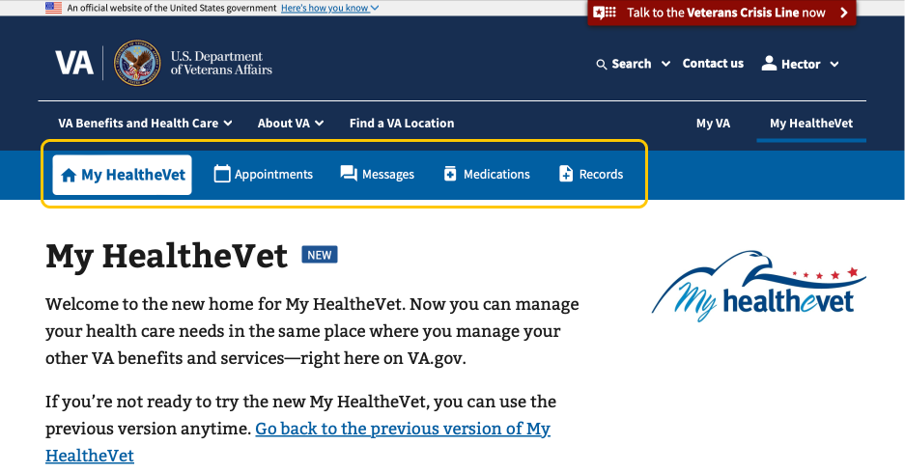

Figure 11. The MHV navigation bar on desktop

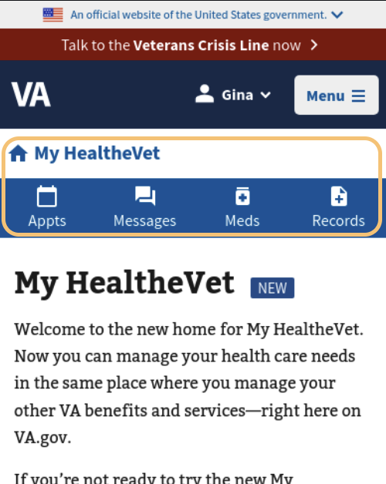

Figure 12. The MHV navigation bar on mobile

## Navigation to the new My HealtheVet experience from VA.gov

### Option 1: VA.gov header (from each page on the site)

**On desktop**

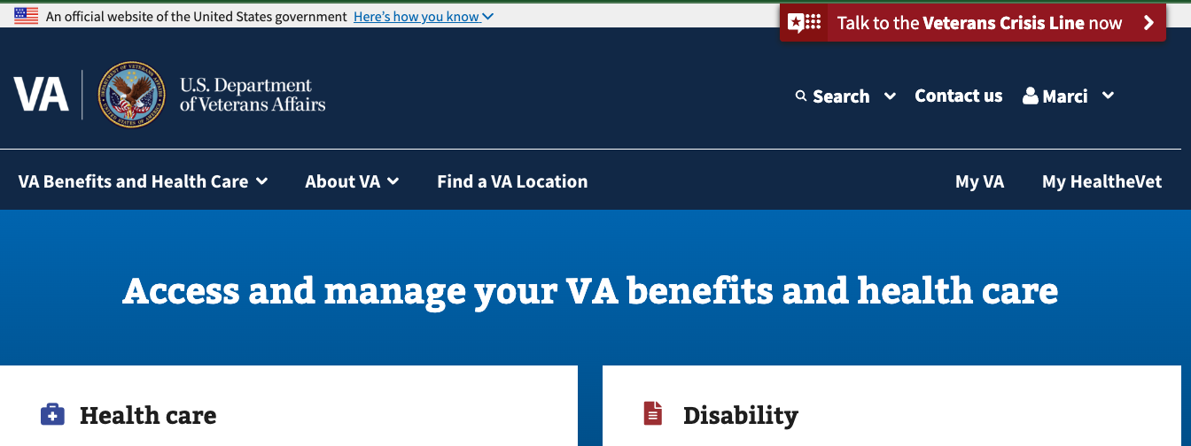Those who sign in to VA.gov on a desktop computer will see a “My HealtheVet” link in the header, which will take them directly to the new My HealtheVet experience landing page. This link is enabled for all signed-in desktop users, regardless of whether they receive VA health care benefits.

Figure 13. Location of My HealtheVet link on desktop header

**On mobile device**

Those who sign in to VA.gov on a mobile device will need to click on the personal name dropdown menu at the top of the screen (this link will be the signed in Veteran’s first name). There they will see the My HealtheVet link, which will take them directly to the new My HealtheVet experience landing page. This link is enabled for all signed-in mobile users, regardless of whether they receive VA health care benefits.

Figure 14. Steps to find My HealtheVet link under the personal name menu on mobile

### Option 2: My VA

**Link available to all signed in ID-proofed users**

All signed in users with ID-proofed accounts can find a link directly to the new My HealtheVet experience landing page on My VA under the heading “Health care.” This link “Go to My HealtheVet” is enabled for all signed in users, regardless of whether they receive VA health care benefits.

**Links available to all signed in ID-proofed users who receive VA health care benefits**

The other links in that same “Health care” section on My VA only show for signed in users with ID proofed accounts who receive VA health care benefits. These links send the user directly to the various health tools on My HealtheVet:

Link text with destination url:

Go to My HealtheVet: www.va.gov/my-health

Schedule and manage appointments: www.va.gov/my-health/appointments

Go to inbox: www.va.gov/my-health/secure-messages/inbox/

Refill medications: www.va.gov/my-health/medications/refill

Get medical records: www.va.gov/my-health/medical-records

Review and file travel claims: www.va.gov/my-health/travel-pay/claims

#### **For Veterans who have received care at an Oracle facility**

Signed in users with ID-proofed accounts who have received care at an Oracle facility will no longer find a yellow alert in the Health care section of My VA. To get from My VA to Oracle’s health portal, users can use the following links: Schedule and manage appointments, go to inbox, refill medications, and get medical records.

For all users that are registered at Oracle health facilities, these tool pages in the new My Healthevet experience will display a yellow alert with the option for users to click to go to My VA health (Oracle’s health portal). More on these yellow Oracle alerts on MHV tool pages later in this document.

Figure 15: Health care section on My VA with links to the new MHV experience

Figure 6. Example of Oracle alert on tool page, in this case Appointments

### Option 3: The health care hub on VA.gov

Whether they are logged in or not, all users can access the health care hub from any page on VA.gov by going into the mega menu (VA Benefits and Health Care), and choosing option “Health care.”

Figure 7. VA.gov megamenu opened to Health care hub option with manage your health links highlighted

Link text with destination url:

Manage health appointments: www.va.gov/health-care/manage-appointments

Refill prescriptions and manage medications: www.va.gov/health-care/manage-prescriptions-medications/

Review medical records online: www.va.gov/health-care/review-medical-records/

Send and receive secure messages: www.va.gov/health-care/send-receive-messages/

File for travel pay reimbursement: https://www.va.gov/health-care/file-travel-pay-reimbursement/

Manage your health care with My HealtheVet on VA.gov (right side of menu): www.va.gov/health-care/manage-health/

All of these destination pages in the health care hub feature a blue sign in widget if the user is logged out. When the user signs in, the blue widget disappears and exposes a new link. The new link takes the user to the new My HealtheVet experience.

**Destination pages for all links in the health care hub “Manage my health” menu**

Figure 18. Page at www.va.gov/health-care/manage-health for users that are not logged in

Figure 19. Page at www.va.gov/health-care/manage-health for users that are signed in and a link to the new My HealtheVet experience. This link sends the user to the My HealtheVet landing page at www.va.gov/my-health

Figure 20. Page at www.va.gov/health-care/manage-appointments for users that are not logged in

Figure 21. Page at www.va.gov/health-care/manage-appointments for users that are signed in and a link to the new My HealtheVet experience. The link “Go to your appointments” brings the user to www.va.gov/my-health/appointments

**For Veterans who have received care at an Oracle health facility**

When these users arrive at www.va.gov/my-health/appointments, they will get a yellow alert offering the option to “Go to My VA Health.”

Figure 22. Alert for Oracle users at www.va.gov/my-health/appointments (new MHV experience)

Figure 23. Page at www.va.gov/health-care/manage-prescriptions-medications for users that are not logged in

Figure 24. Page at www.va.gov/health-care/manage-prescriptions-medications for users that are signed in and a link to the new My HealtheVet experience. The link “Go to your medications” brings the user to www.va.gov/my-health/medications?page=1

**For Veterans who have received care at an Oracle health facility**

When these users arrive at www.va.gov/my-health/medications?page=1, they will get a yellow alert offering the option to “Go to My VA Health.”

Figure 25. Alert for Oracle users at www.va.gov/my-health/medications?page=1 (new MHV experience)

Figure 26. Page at www.va.gov/health-care/review-medical-records for users that are not logged in

Figure 27. Page at www.va.gov/health-care/review-medical-records for users that are signed in and a link to the new My HealtheVet experience. The link “Go to your medical records” brings the user to www.va.gov/medical-records

**For Veterans who have received care at an Oracle health facility**

When these users arrive at www.va.gov/my-health/medical-records, they will get a yellow alert offering the option to “Go to My VA Health.”

Figure 28. Alert for Oracle users at www.va.gov/medical-records (new MHV expeerience)

Figure 29. Page at www.va.gov/health-care/send-receive-messages for users that are not logged in

Figure 30. Page at www.va.gov/health-care/send-receive-messages for users that are signed in and a link to the new My HealtheVet experience. The link “Go to your medical records” brings the user to www.va.gov/my-health/secure-messages/inbox

**For Veterans who have received care at an Oracle health facility**

When these users arrive at www.va.gov/my-health/secure-messages/inbox, they will get a yellow alert offering the option to “Go to My VA Health.”

Figure 31. Alert for Oracle health users at www.va.gov/my-health/secure-messages/inbox

Figure 32. Page at www.va.gov/health-care/file-travel-pay-reimbursement for users that are not logged in

Figure 33. Page at www.va.gov/health-care/ file-travel-pay-reimbursement for users that are signed in including two links to the new My HealtheVet experience. The link “Go to your past appointments” brings the user to /my-health/appointments/past. The link “Review your travel claims” goes to www.va.gov/my-health/travel-pay/claims